Complete Java Developer Course Notes

Section 1: Introduction

Terminology:
- IDE (Integrated Development Environment) – where we will code
- Compiler – the program that converts your source code (Java) into bytecode, which is what the JVM (Java virtual machine) understands.

IntelliJ IDEA
The IDE that we will be using in the course. It works on Windows, MacOS, and Linux platforms.

Section 2: Introducing Java

Overview
- Fundamentals
  - Printing information to the console
  - Variables, values, and constants
  - Data types
- Operators
  - Arithmetic
  - Relational
  - Logical
- User Input

Variables, Constants, and Data Types
- Writing software involves working with instructions and data
- Data in Java:
  - Variables, constants
  - Data types
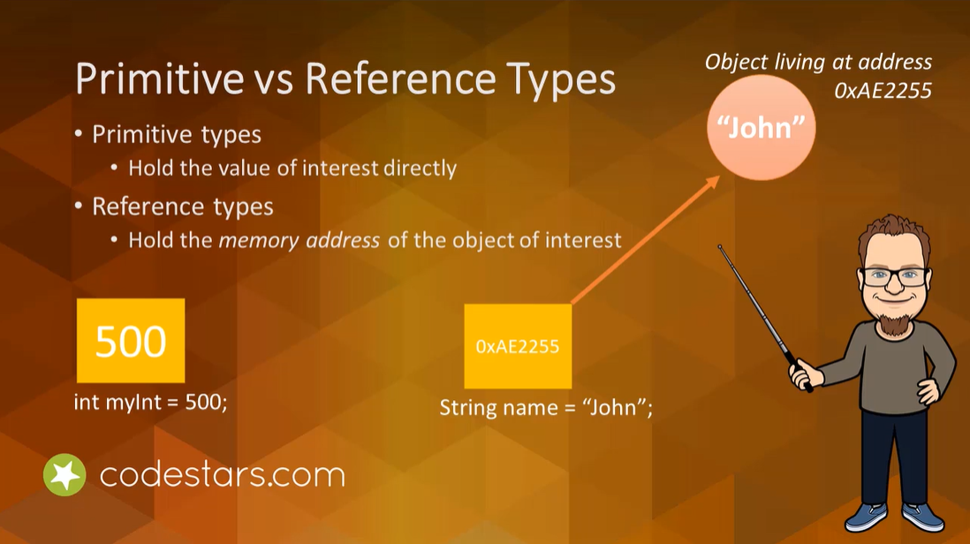
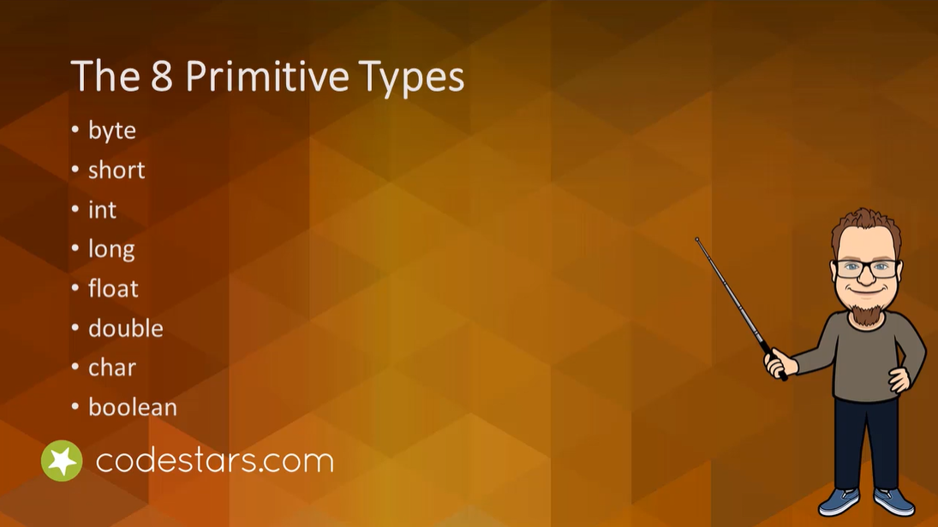

Comments
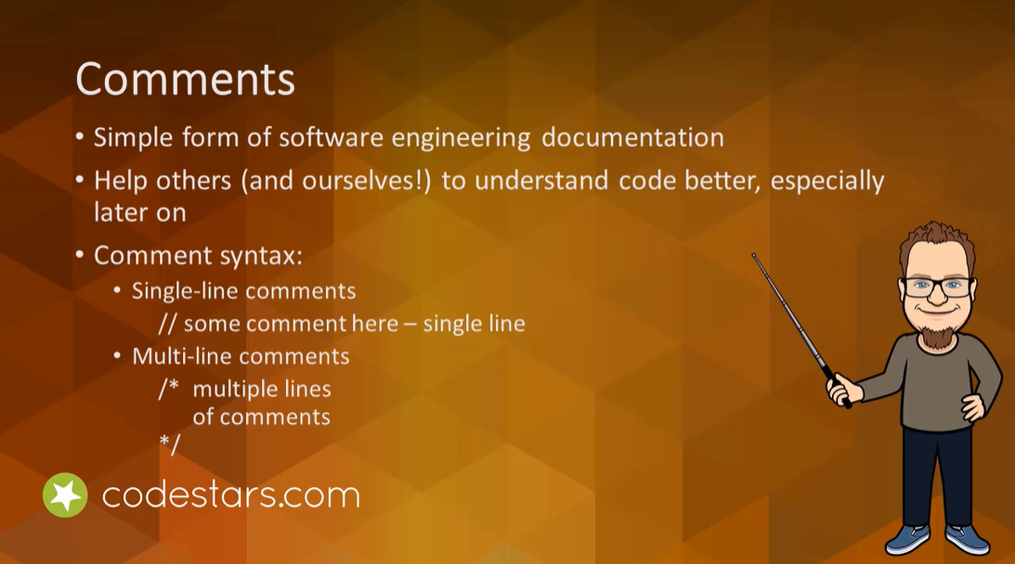

Arithmetic Operators
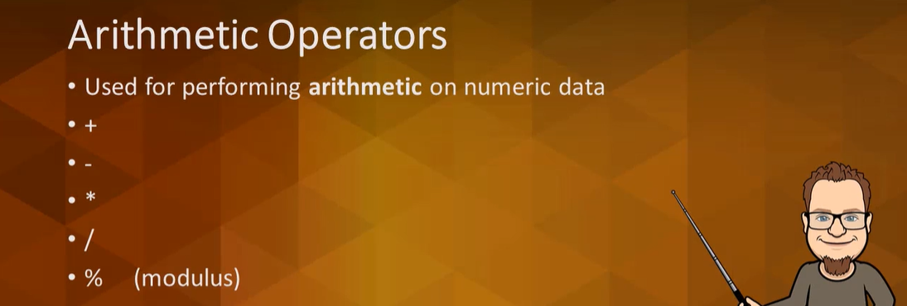
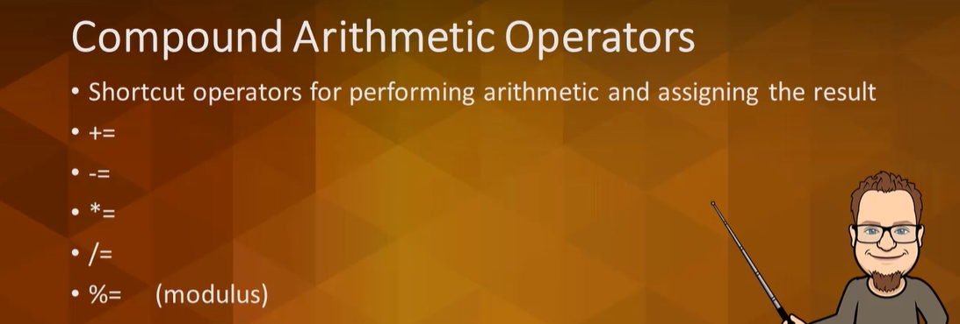
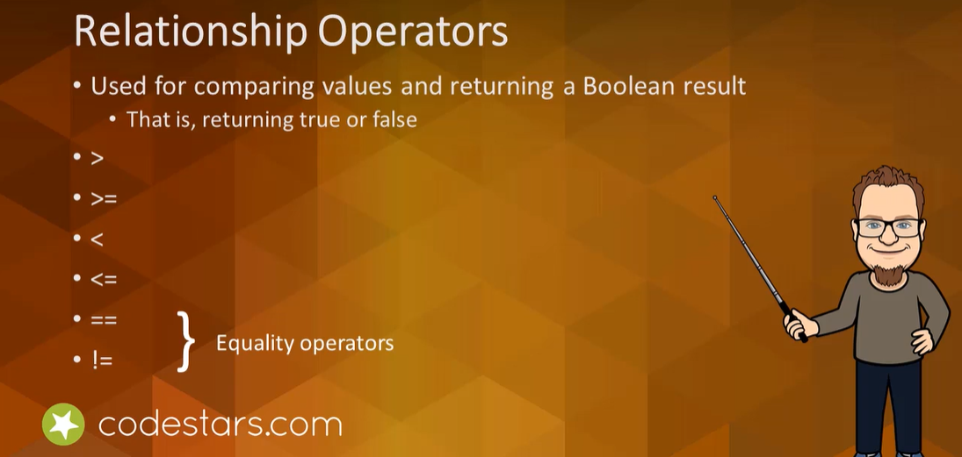
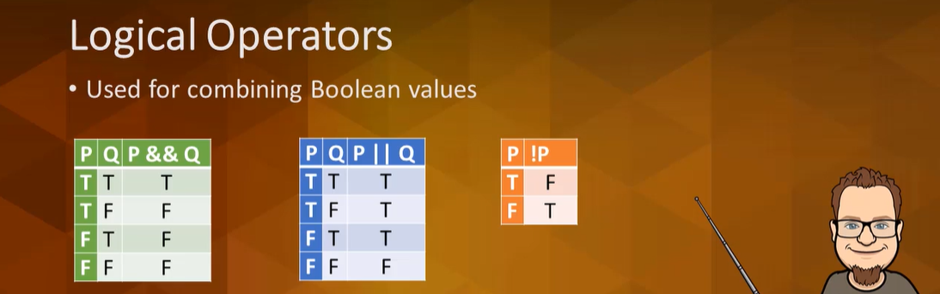
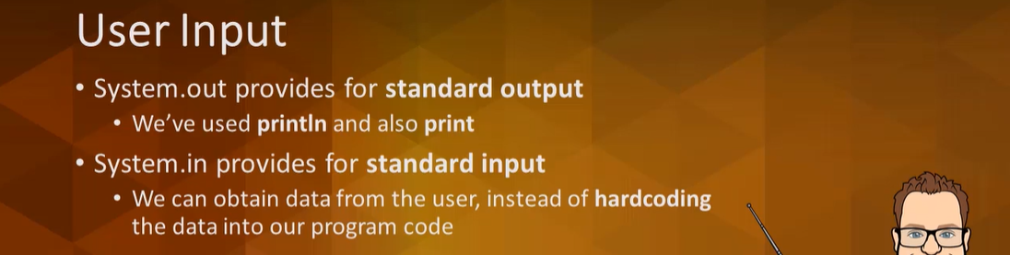
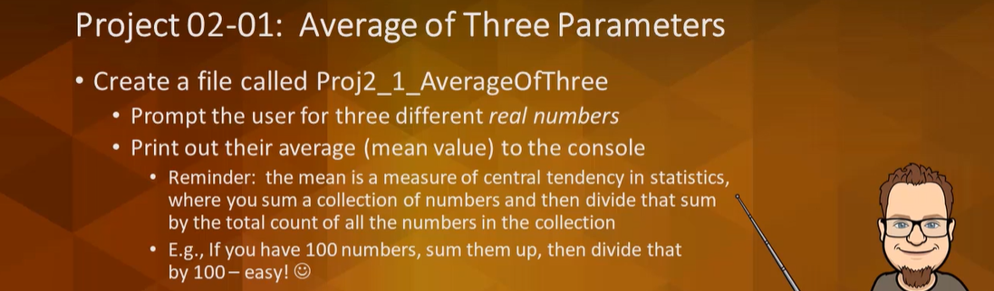

Section 3: Control Statements

Overview
Control Flow
- The order in which instructions are executed in a program

Control Statements
- Help developers to create extremely powerful computer programs
- Three categories:
  - Sequence (sequential)
  - Selection
  - Repetition
- Also: Break and Continue

Random Numbers (pseudo-random numbers)

Control Statements

Control Statements
- Control Flow – the order in which instructions are executed within a program
- With control statements, we can produce exciting and sophisticated applications

Selection Control Statements

Different Selection Control Statements:
- The if-statement
- The if-else statement
- The switch statement

Repetition Control Statements

- The while loop
- The do-while loop
- The for loop

Continue and Break

In some cases, we might want to have our code end early or skip certain iterations. This is what we will use continue and break statements for.

Random Numbers

Pseudo-random number generators (PRNGs)
- Produce sufficiently random values for our purposes. A thorough mathematical discussion regarding their implementation is beyond the scope of this lecture.

Section 4: Arrays and ArrayLists

Overview
Data Structures
- Containers that hold data

Arrays and ArrayLists
- ArrayLists live in java.util package
- Regular built-in arrays that Java provides as part of the language.

With these data structures, it is possible to store more than one piece of data at a time using a single variable identifier.

Being able to use these fundamental data structures is key for success in the software development industry.

Arrays
In an array, all of the elements must be of the same data type.

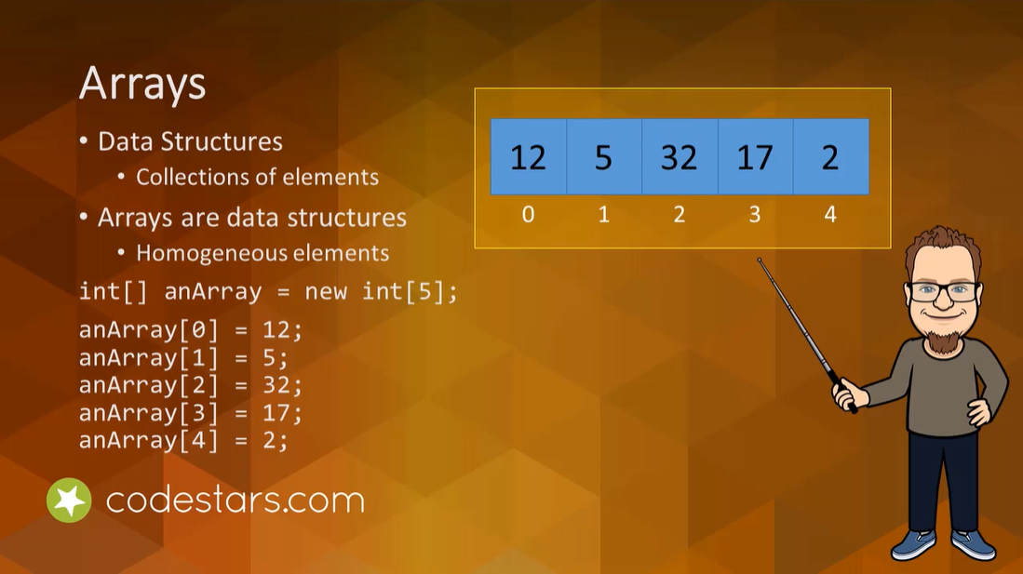

ArrayLists


Wrapper Classes
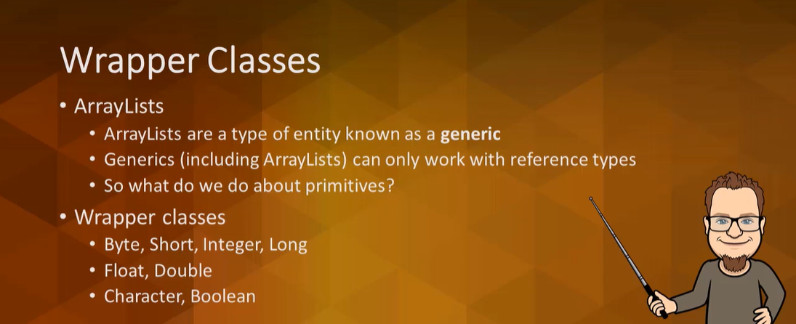

Wrap-up
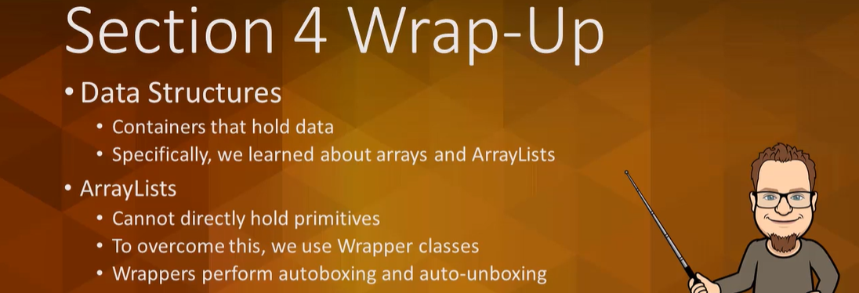

Section 5: Strings and the StringBuilder Class

Overview
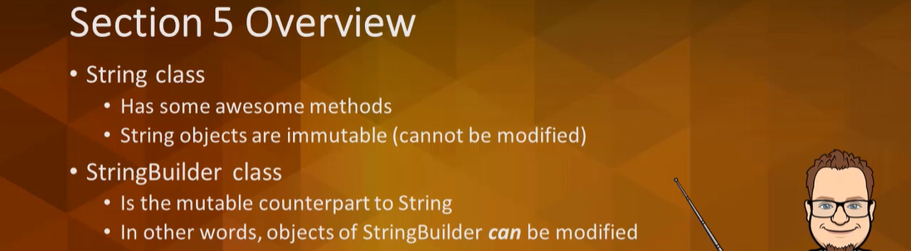

String Methods: Part 1
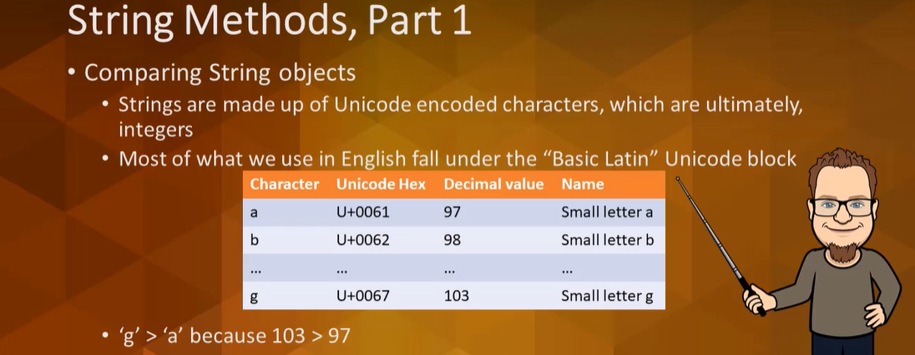
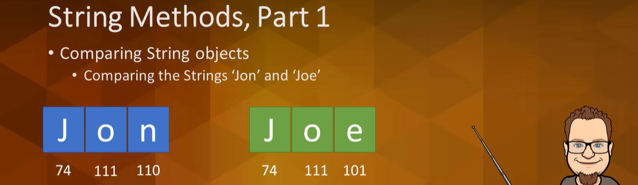

String Methods: Part 2
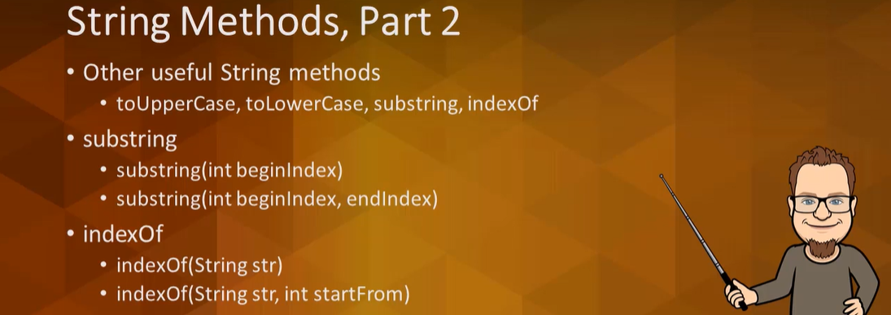

The StringBuilder Class
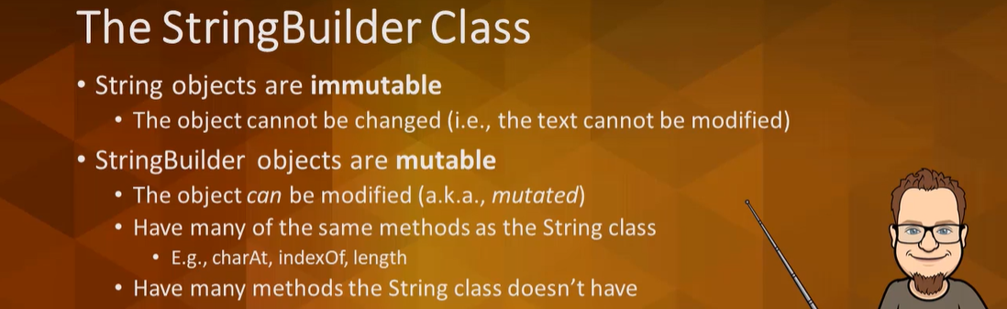

Wrap-Up
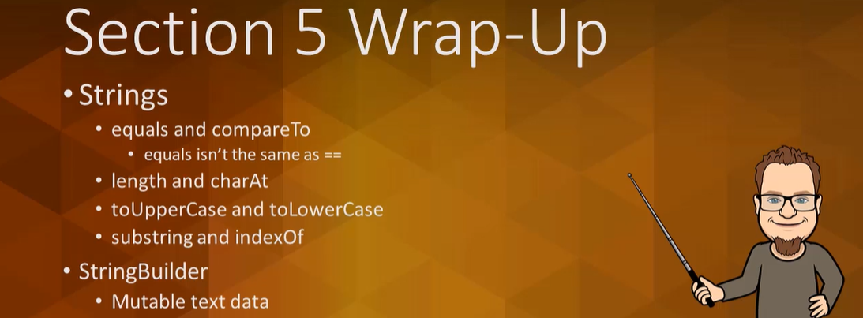

Section 6: Methods

Overview
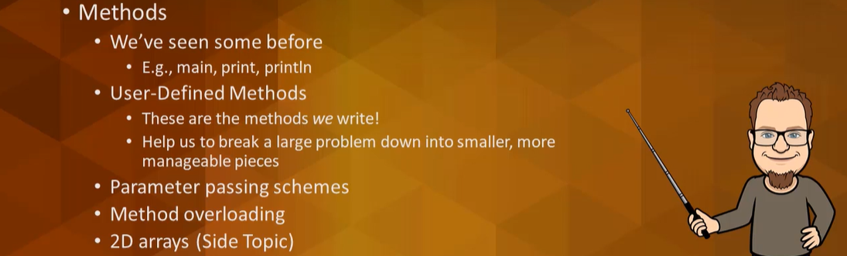

User-Defined Methods: Part 1
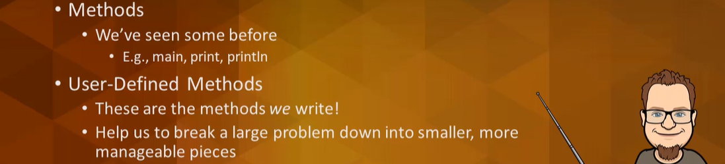

User-Defined Methods: Part 2
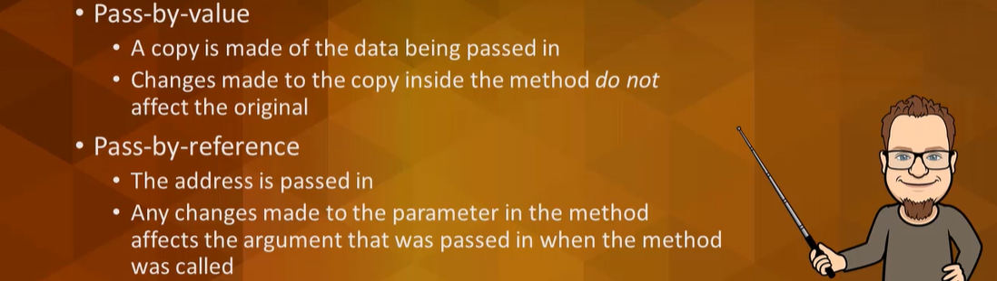

Method Calls and Recursion
Methods
- You write the definition
- You call or invoke them to get them to actually execute the code from the definition
We’ve called methods from the main method, but you can call any method from any other method.

Recursion – when a method calls itself.

For a method to be recursive, it needs:
- At least one base case (no recursion in this case)
- At least one recursive case (this is where recursion occurs

Stacks
- You can only add and remove items from the top of the stack
- Adding an item to a stack is called pushing an item onto the stack
- Removing an item is called popping the item off of the stack

When any method is called, not just recursive methods, an activation record, also called a stack frame, is pushed onto the top of the stack. In general, stacks are data structures that can hold practically anything. But for methods, the runtime environment maintains the method call stack. And this stack holds activation records or stack frames.

These activation records hold information about the particular method called, the memory location of that call, the value of the parameters and local variables, where in the method the last instruction was executed, etc.

2D Arrays (Side Topic)
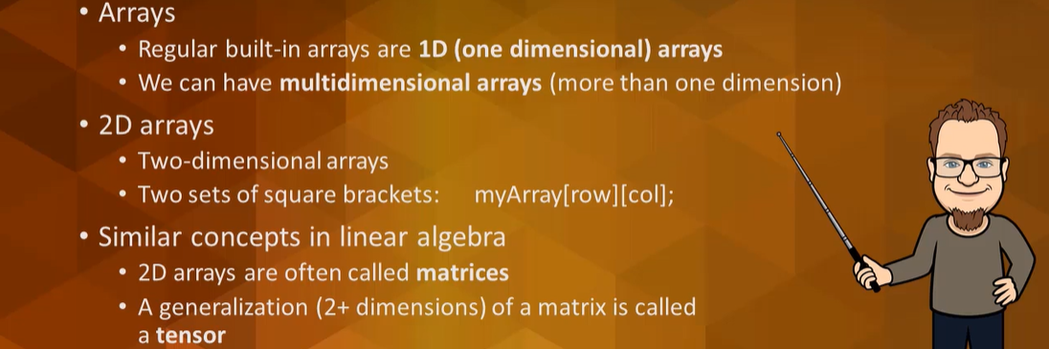

Project – Tic-Tac-Toe
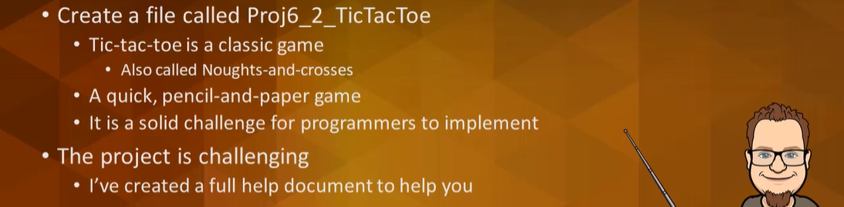

Wrap-Up
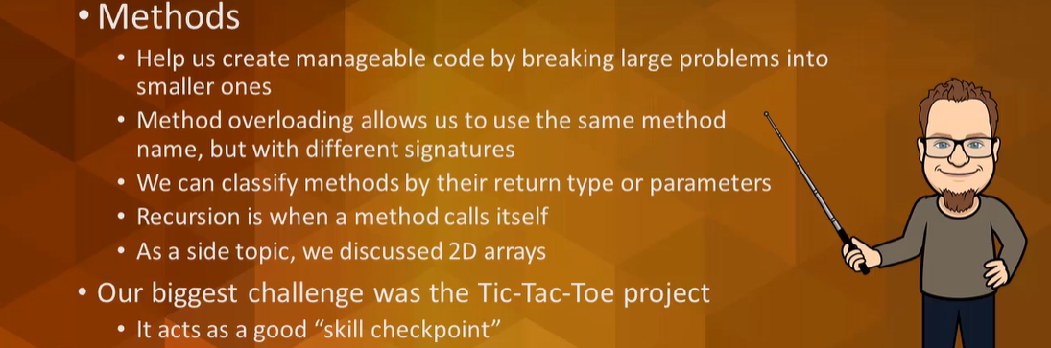

Section 7: Introduction to Classes and Objects

Overview
OOP (Object-Oriented Programming)
- Focus is on objects, which have behaviors and data
- Classes are used to create objects
- Some classes that will be worked on: House, Rectangle, Book classes
- Projects to be completed: BankAccount, IceCream, Circle classes
- UML (Unified Modeling Language)
  - UML class diagrams help organize and describe classes

Basics of OOP
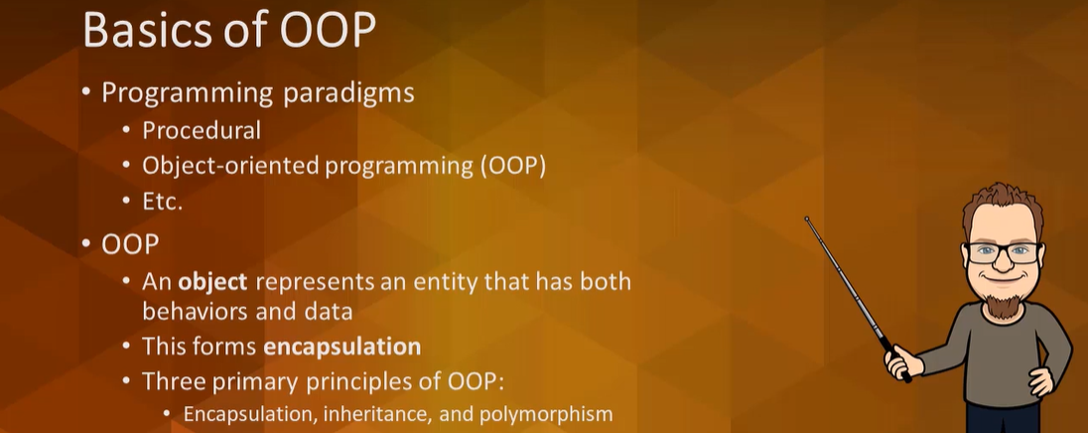

Encapsulation: Fields and Methods
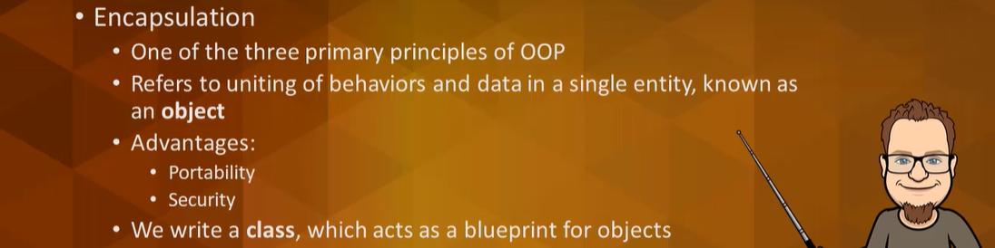

Setters are called mutators and getters are called accessors.

A Rectangle Class
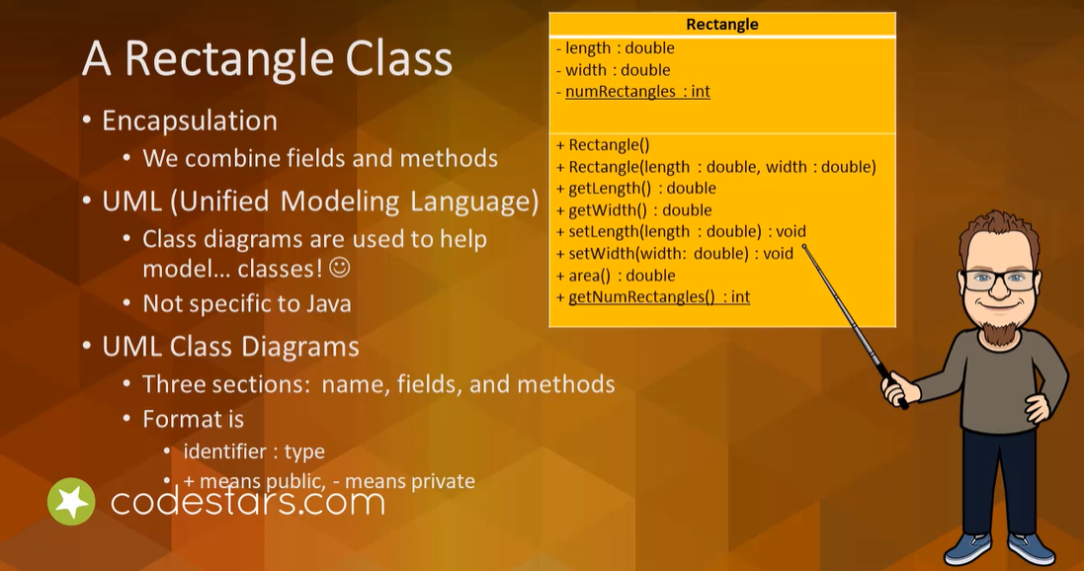

Book Class
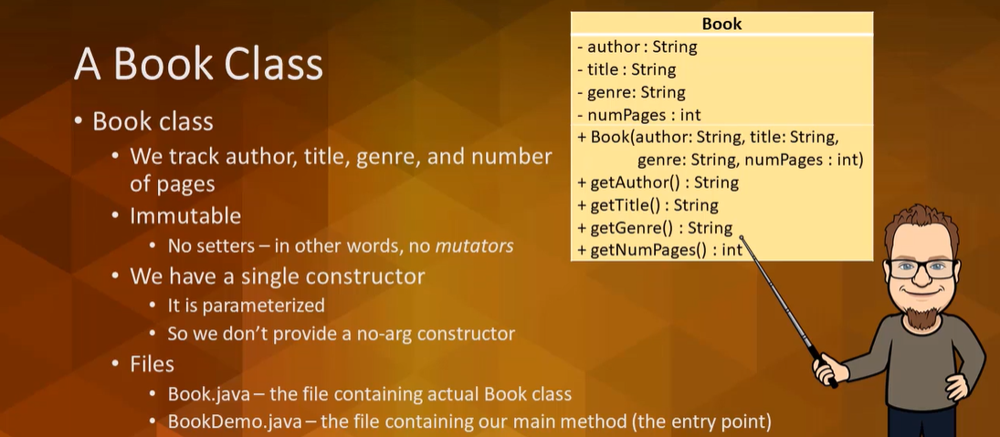

Bank Account Class
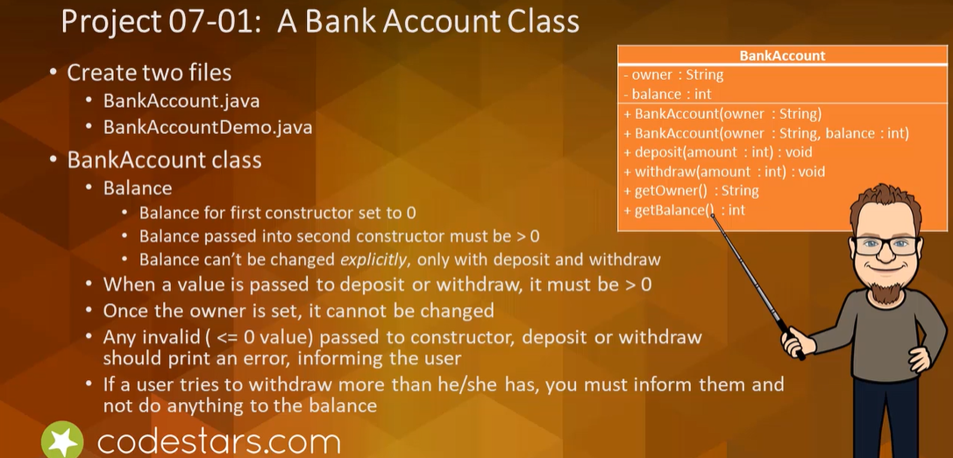

Ice Cream Class
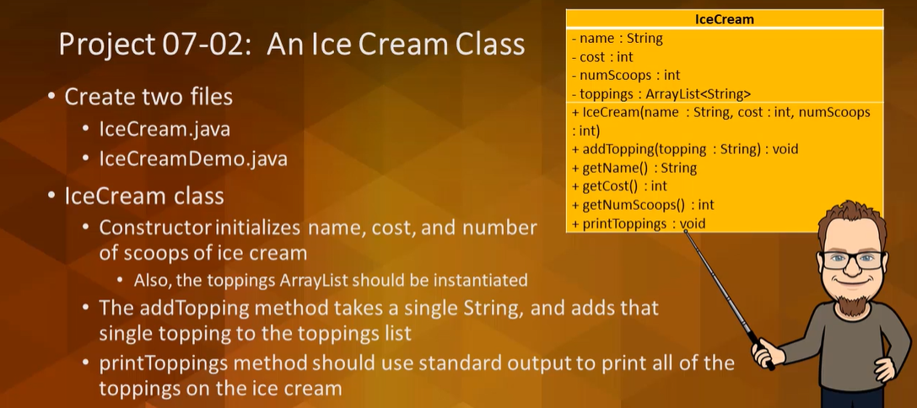

Circle Class
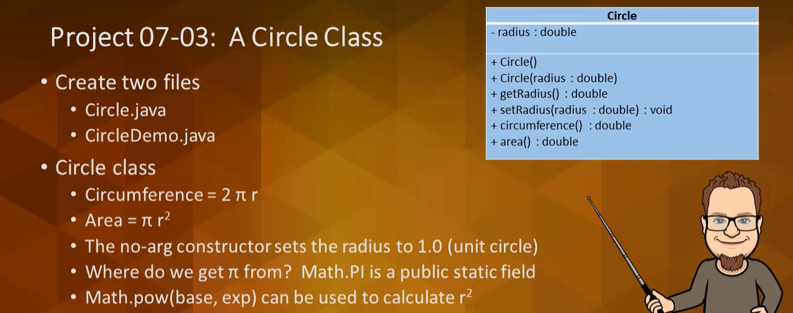

Wrap-Up
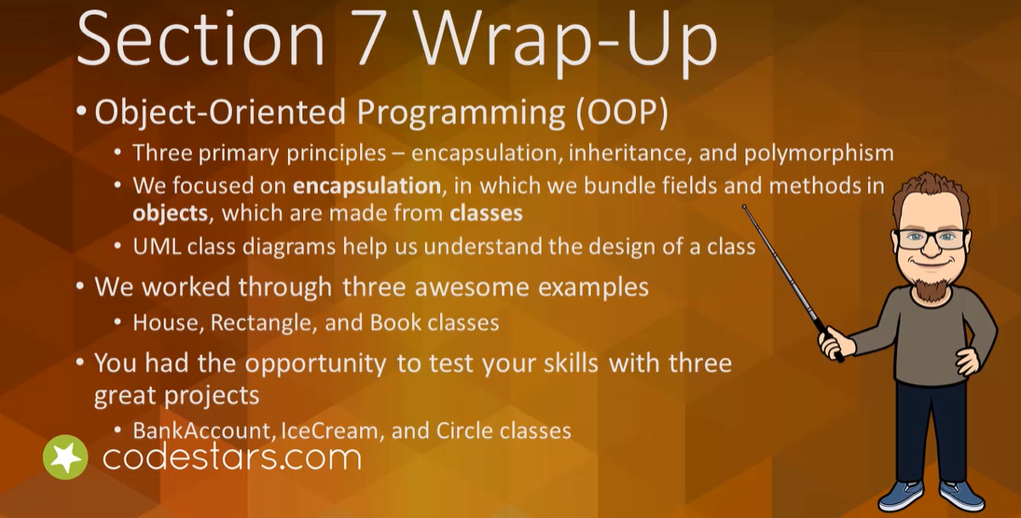

Section 8: File I/O and Exceptions
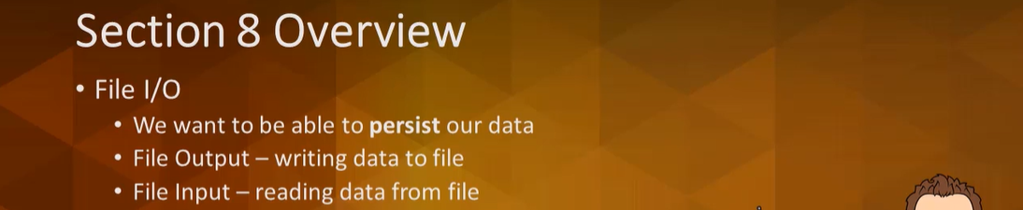

File Input
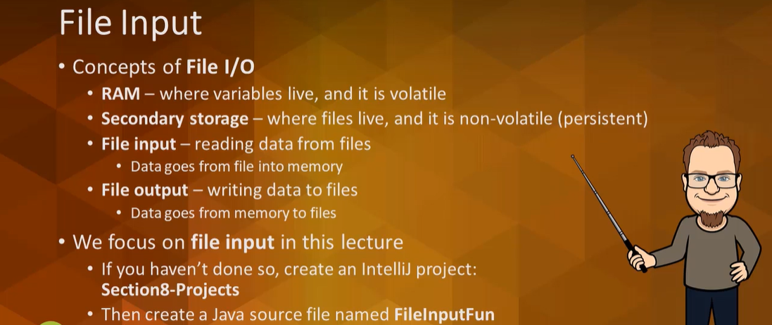

File Output
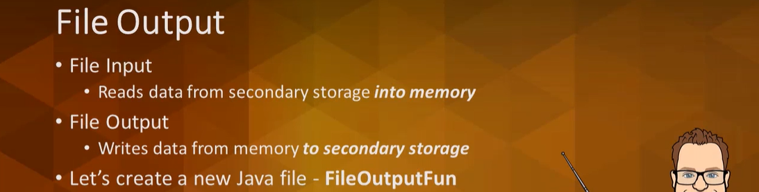

More File I/O
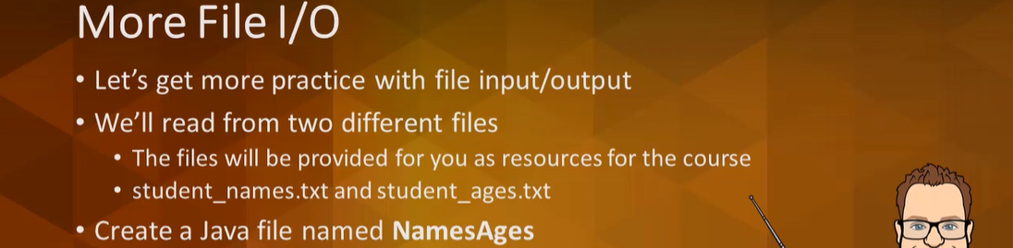

Project 1 - Creating Rectangles from a File
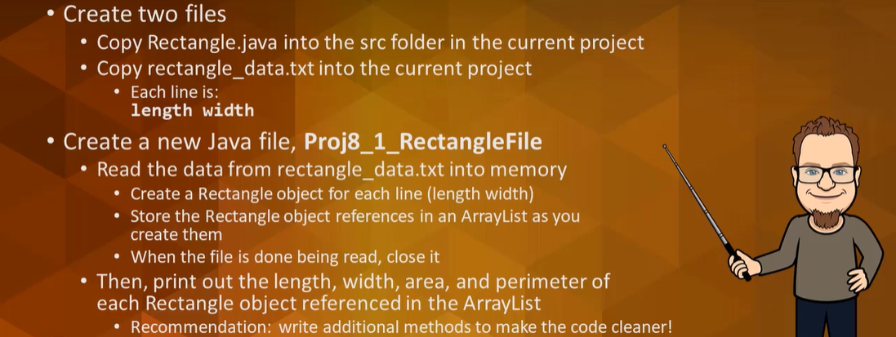

Project 2 – Creating Circles from a File
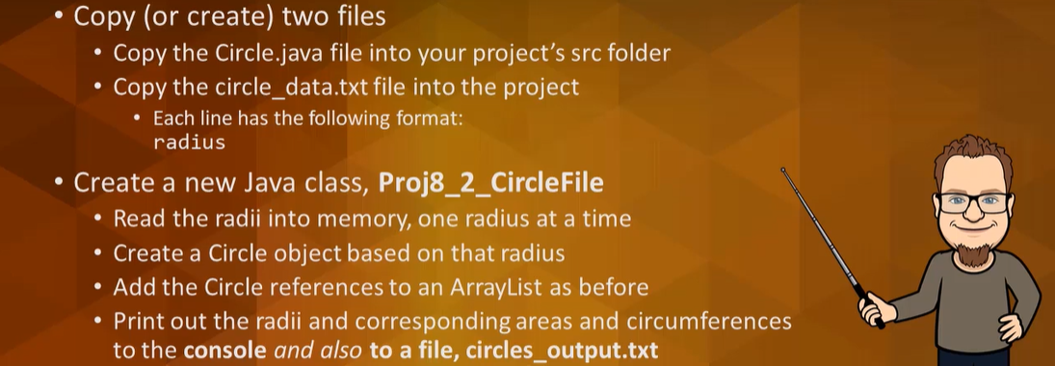

Wrap-Up
